|  |  |
| --- | --- |
| Assessment Title | CLD401ACF- Assignment 1 – Select Cloud Solution |

## Competency Details

|  |  |
| --- | --- |
| Unit code/s and title/s | ICTCLD401 - Configure cloud services (Release 1) |
| Qualification code/s and title/s | National Code: ICT40120 Certificate IV in Information Technology |
| Business unit/Work group | Business and Arts / IT Studies |

## Instructions

|  |  |
| --- | --- |
| Method/s of assessment | Questioning (Written) |
| Overview of assessment | This assessment will require you to demonstrate your ability to identify, define, compare, and select cloud services, identity industry standards, cost models and security responsibility models. |
| Task/s to be assessed | This assessment will require you to complete the following tasks  Project case and written questions   * Task 1: Select cloud computing services and solutions * Task 2: Identify user access protocols and Policies * Task 3: Identify Impact of shared security responsibility model * Task 4: Define workload * Task 5: Explain Industry technology standards * Task 6: Compare Cost Models * Task 7: Understand security responsibility models |
| Time allowed | Refer to your schedule for submission dates |
| Location of assessment | Assessment can be completed anywhere with access to the resources required. (see Resources Required section below) |
| Decision making rules | To receive a satisfactory outcome for this assessment you must complete all parts correctly.  Word counts are provided as guidance only. |
| Assessment conditions | This assessment must be undertaken where the conditions replicate noise levels and interruptions that people typically experience working in the ICT industry.  This is an unsupervised assessment and you may access any required resources.  This is not group work and must be completed as an individual. |
| Resources required | To complete this assessment, you will require the following:   * Access to Learn with Internet access * Learn resources * Word processing software such as Microsoft Word. * AWS account to be able to perform the tasks * AWS learning site to perform the tasks * ICTCLD401 - ASDS - Organisational Requirement.docx |
| Result notification and reassessment information | You will be provided feedback and the result for your assignment on TAFESA Learn. You will be and given the chance to resubmit with required corrections only once.  Refer to the TAFE SA assessment policy for more information <https://www.tafesa.edu.au/apply-enrol/before-starting/student-policies/assessment> |

## Task 1: Select cloud computing services and solutions

You are required to select the cloud computing solutions, deployment models and service models that would meet the business requirements (File: ICTCLD401 - ASDS - Organisational Requirement.docx) of Erfys Confectionary.

1. Discuss and compare the following features of Azure and AWS cloud computing solutions that will support website compute and storage. List 3 features of each example.

Answer:

|  |  |  |
| --- | --- | --- |
|  | Feature: Compute | Feature: Storage |
| AWS | ***EC2 (Elastic Compute Cloud):***  ***Scalability:*** *EC2 instances can be easily scaled up or down based on demand.*  ***Customizable Instances:*** *EC2 offers a wide variety of instance types.*  ***Pay-As-You-Go Pricing:*** *EC2 uses a pay-as-you-go pricing model, so you only pay for the compute capacity you use.* | ***S3 (Simple Storage Service):***  ***Durability and Availability:*** *Amazon S3 offers great durability of data via replicating it across multiple locations within a region.*  ***Scalability:*** *S3 automatically scales to handle large volumes of data.*  ***Storage Classes:*** *S3 offers various storage classes (Standard, Intelligent-Tiering, Glacier, etc.) that allow users to store data at different price points depending on access frequency.* |
| Azure | **Virtual Machines (VMs):**  ***Wide OS Support:*** *Azure VMs support a range of operating systems, including Windows, Linux, and custom OS builds, providing flexibility for different environments.*  ***Hybrid Cloud Capabilities:*** *Azure VMs offer seamless integration with on-premises systems, making it easy to run a hybrid cloud environment where workloads can move between on-premises and cloud as needed.*  ***High Availability:*** *With Azure VMs, you can set up Availability Zones and Fault Domains to ensure that your applications remain highly available even in case of hardware failures.* | **Blob Storage:**  ***Massive Scale for Unstructured Data:*** *Azure Blob Storage is designed for unstructured data, allowing you to store a virtually limitless amount of data.*  ***Tiers for Cost Optimization:*** *Similar to S3, Azure Blob Storage offers different tiers (Hot, Cool, Archive) based on the frequency of data access, helping optimize storage costs.*  ***Integration with Other Azure Services:*** *Blob Storage seamlessly integrates with Azure’s ecosystem, making it easy to use with other services.* |

1. Discuss and compare the functions of the following deployment models that would apply to the organisation.

Answer:

|  |  |  |  |  |
| --- | --- | --- | --- | --- |
|  | Feature: Cost | Feature: Erfy’s Responsibility | Feature: Deployment Complexity | Two Applications (Uses) |
| Model 1 (Public Cloud) | **Low** | **Low:** Most responsibilities, including infrastructure management and maintenance, are handled by the public cloud provider. | **Low:** Deployment is relatively simple as the public cloud provider handles the complex tasks of setting up and maintaining the infrastructure. | - Hosting public-facing websites with high traffic demands.  - Running test and development environments for quick scaling and low cost. |
| Model 2 (Private Cloud) | **High** | **High:** Erfy is responsible for managing and maintaining the entire infrastructure, including hardware, software, and security. | **High:** Setting up and maintaining a private cloud requires significant IT expertise, as all hardware, software, and networking must be managed internally. | - Handling sensitive customer data  - Running custom business applications/enable organizations to tailor infrastructure and services to their specific needs |
| Model 3 (Hybrid Cloud) | **Middle** | **Middle:** Erfy would manage part of the infrastructure (private cloud) while the public cloud provider handles the rest. | **Middle:** Hybrid cloud deployments can be complex, requiring seamless integration and communication between public and private cloud resources, along with security management across both environments. | - Disaster recovery solutions, where critical applications are run on the private cloud and failover to the public cloud.  - Dynamic scaling of workloads, where day-to-day operations run on private infrastructure, but additional demand is handled by the public cloud. |

1. Discuss and compare three service models that would apply to the organisation.

Answer:

|  |  |  |  |  |  |
| --- | --- | --- | --- | --- | --- |
|  | Description | Feature: Cost | Feature: Erfy’s Responsibility | Feature: Deployment Complexity | Principles: |
| Model 1 (IaaS) | Provides virtualized computing resources like servers, storage, and networking. Users have control over the infrastructure and can install any OS or applications. | High | High**:** Erfys is responsible for managing the virtual machines, OS, middleware, and runtime. Only the underlying infrastructure ( physical hardware and data center operations) is managed by the provider. | High | - Provides virtual machines, storage, and networks.  - Ideal for organizations requiring flexibility and control over their infrastructure. |
| Model 2 (PaaS) | Provides a platform for developing, running, and managing applications without the complexity of managing the underlying infrastructure. | Middle | Middle**:** Erfys manages the applications and data, while cloud provider is responsible for managing the underlying infrastructure and platform components | Middle | - Offers a managed environment for application development.  - Best suited for organizations needing a development platform without managing infrastructure. |
| Model 3 (SaaS) | Delivers fully managed software applications over the internet, where users simply access and use software without managing any infrastructure or platform components. | Low | Low**:** Erfys only needs to manage user access and data. The service provider manages everything else, including applications and infrastructure. | Low | - Delivers ready-to-use software via the web.  - Best for organizations looking for easy-to-use, fully managed software solutions. |

1. Recommend the cloud computing solution, deployment model and service model with justifications. (Approximately 100 words)

**Cloud computing solution:** Amazon **AWS** is recommended as it provides high availability, scalability, and security features, all crucial for Erfys Confectioneries' global operations. AWS also offers a wide range of services to support the migration from on-premises infrastructure.

**Deployment model:** The **Hybrid Cloud** model is ideal, as it combines the scalability and cost-effectiveness of the public cloud for non-sensitive operations while using a private cloud for critical data. This offers flexibility and control while optimizing costs.

**Service model:** The **PaaS (Platform as a Service) model** is recommended, as it simplifies application development and management, reducing Erfys’ responsibility for infrastructure while ensuring scalability and rapid deployment.

## Task 2: Identify user access protocols and Policies

Erfys Confectionary wants to secure access to cloud services for department members. Identify which access policy (identity-based or Resource-based) should Erfys adopt based on the “**Account and resource access requirements**” of the organisational requirements (File: ICTCLD401 - ASDS - Organisational Requirement.docx). Identify two security access protocols that can provide a secure connection to the cloud services.

Answer:

Choice of access policy mode: Erfys Confectionary should adopt an **Identity-based access policy**. This policy aligns with their requirements of managing user access securely by assigning permissions based on job roles and groups. It allows precise control over individual access rights, ensuring that each department member only has the necessary permissions. It also supports multi-factor authentication (MFA), encryption, and user-specific access privileges.

Security access protocols:

* **Password policy with a minimum password of 12 characters:** Strong password are essential to reducing the risk of brute force attacks. To ensure passwords are strong one should include a combination of uppercase letters, lowercase letters, numbers, and special characters to ensure complexity.
* **Full access accounts require multi-factor authentication enabled**: MFA adds an extra layer of protection by requiring users to provide two or more verification factors (e.g., a password and a one-time code sent to a mobile device) to access accounts. This ensures that even if a password is compromised, unauthorized access can be prevented through the second factor.

## Task 3: Identify Impact of shared security responsibility models:

Erfys Confectionary would like to know the responsibilities of the different service models.

As an impact of the shared security responsibility model describe one responsibility the customer has with IaaS.

**Answer:** With IaaS, Erfys is responsible for securing and maintaining the operating system, applications, and any data hosted on the infrastructure. This includes patching the OS, configuring firewalls, and managing security settings for the applications

As an impact of the shared security responsibility model describe one responsibility the customer has with PaaS.

**Answer:** While the platform and infrastructure are managed by the cloud provider, Erfys is responsible for securing the applications they deploy on the platform, including configuring authentication, ensuring proper encryption of sensitive data, and managing user access

As an impact of the shared security responsibility model describe one responsibility the customer has with SaaS.

**Answer:** In SaaS, most infrastructure and application security is handled by the provider. However, Erfys is responsible for managing user permissions, access control, and ensuring that data entered into the SaaS application is protected, including monitoring access and managing multi-factor authentication (MFA).

## Task 4: Define workload:

Based on business requirements and needs of Erfys Confectionary, define six workloads (Services) that will address the requirements as per the “**Workload service requirements**” section (File: ICTCLD401 - ASDS - Organisational Requirement.docx).

**Answer:**

1. User and Workload Permissions Management:

AWS Identity and Access Management (IAM) will manage users, roles, and permissions across the cloud environment, ensuring secure access control.

1. Global Traffic Management:

Amazon Route 53 will manage domain names, handle DNS requests, and route traffic globally, ensuring efficient traffic management for the website and other cloud resources.

1. Scalable Compute Capacity:

Amazon EC2 will provide resizable compute capacity to support various workloads, including website hosting and database management, with the ability to scale up or down based on demand.

1. Object Storage and Data Retrieval:

Amazon S3 will offer object storage for website content, backups, and large datasets, with easy retrieval of data from anywhere, supporting metadata and HTTP URL-based access.

1. Scalable Relational Database:

Amazon RDS (Relational Database Service) will provide scalable database solutions compatible with MySQL and Oracle, ensuring data redundancy, backups, and high availability for critical business operations.

1. Cost and Usage Analysis:

AWS Cost Explorer will visualize and manage cloud costs, enabling Erfys to monitor usage and optimize expenditure, ensuring that cloud resources are used efficiently​

## Task 5: Explain Industry technology standards:

Erfys Confectionary wants to know the industry technology standards that are used by the cloud suppliers. Briefly explain the industry technology standards listed below for cloud computing solutions and services? (Approximately 100 words)

• ISO/IEC 17788

• ISO/IEC 17789

• ISO/IEC 27001

**Answer:**

**ISO/IEC 17788:**

This standard defines the basic concepts and terminology for cloud computing. It outlines the roles, deployment models (public, private, hybrid), and service models (IaaS, PaaS, SaaS), providing a common vocabulary and framework for cloud services.

**ISO/IEC 17789:**

This standard builds on ISO/IEC 17788, specifying the cloud computing reference architecture. It details the interactions between cloud actors (such as cloud providers, customers, and auditors) and the components involved in delivering cloud services.

**ISO/IEC 27001:**

A global standard for information security management, it specifies requirements for establishing, implementing, maintaining, and improving an information security management system (ISMS). It helps cloud providers ensure the confidentiality, integrity, and availability of customer data

## 

## Task 6: Compare Cost Models

A． Erfys Confectionary wants to compare the cost of the current on-premises server and network service with AWS cloud services. Compare the cost of the current server in 3 years <https://servertailor.com> or other online resources for quoting) with AWS EC2 instance services in two types of economic models (No upfront, All upfront) from website <https://calculator.aws/> ? List the 2 benefits of each economic model.

Answer:

|  |  |  |
| --- | --- | --- |
| Economic Models for Compute | Compare the cost  (Total in 3 years) | 2 benefits |
| **On-Premises** | $8,275 | N/A |
| **IaaS with No upfront cost** | $9671.04 | - Flexible pay-as-you-go model.  - No large initial investment, better for cash flow management. |
| **IaaS with all upfront cost** | $8777.52 | - Lower total cost over time with upfront discounts.  - Predictable long-term costs, avoiding potential cost fluctuations. |

Insert your screenshot of all quotation results:

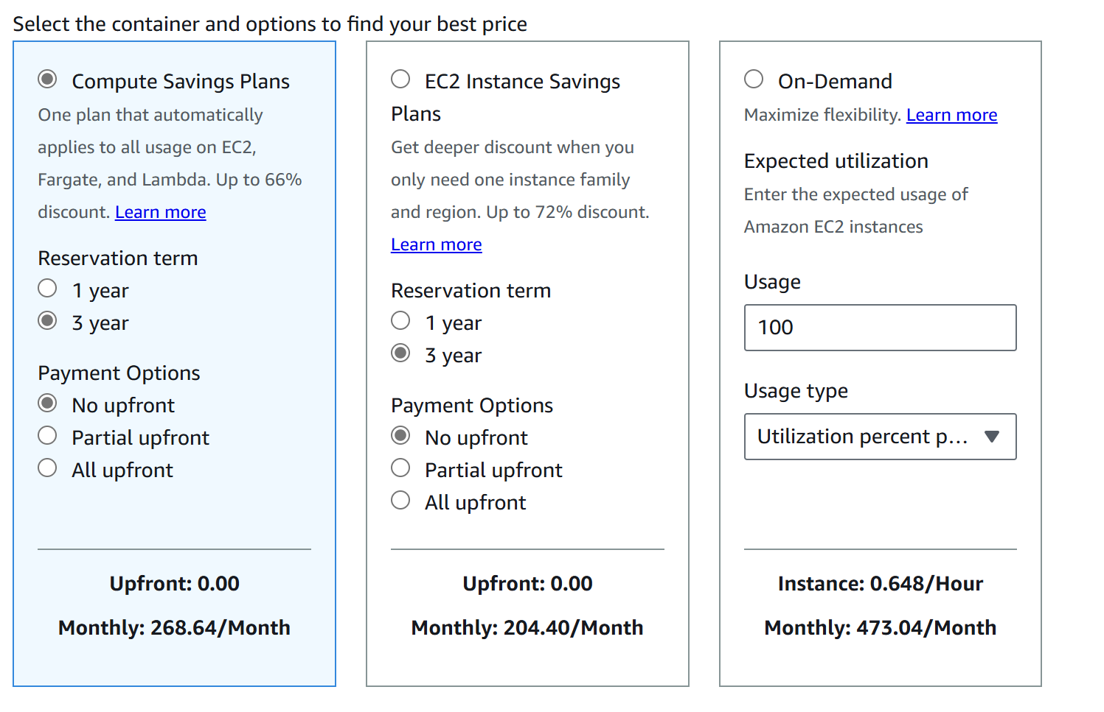

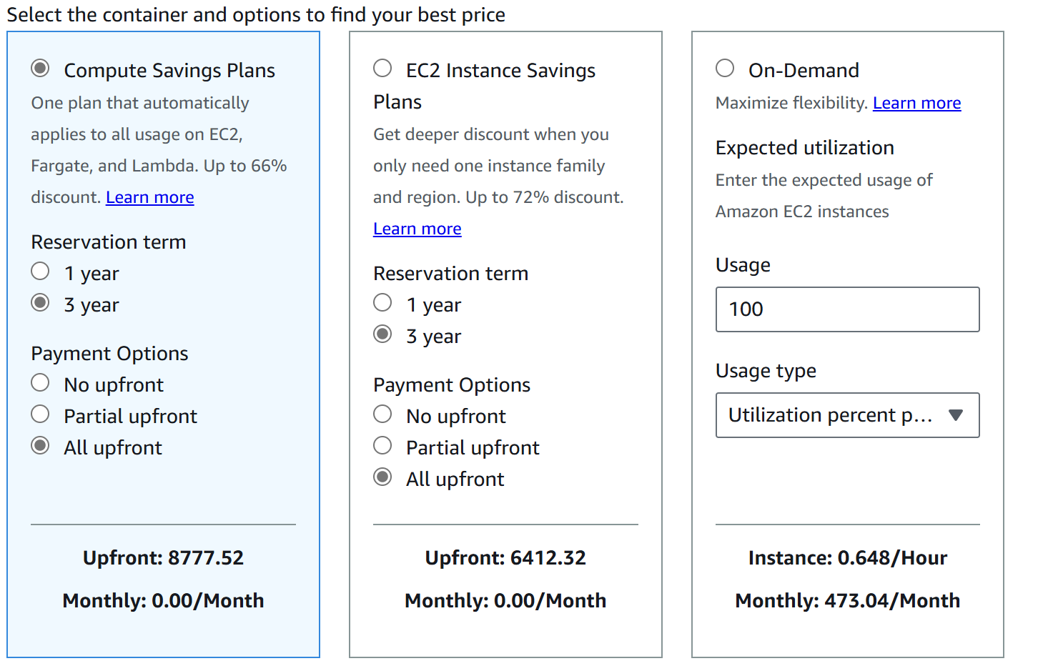

## Task 7: Understand security responsibility models

1. Erfys Confectionary would like to know the owners of responsibilities (AWS, Erfys or the customer) once workloads have been migrated to the Cloud. List 3 service responsibilities according to the service models for IaaS and PaaS?

Answer:

|  |  |  |
| --- | --- | --- |
| Cloud service models | IaaS | PaaS |
| Erfys Confectionary is responsible for | Managing and securing the OS, applications, and data on the infrastructure (e.g., patching, configuring firewalls, and maintaining applications). | Securing applications they deploy, managing user access, and ensuring data encryption and security within their applications. |
| AWS cloud service is responsible for | Maintaining the underlying infrastructure, including physical servers, networking, and virtualisation. | Managing the platform, including infrastructure, OS, and runtime environment. |
| User (Customer) is responsible for | Ensuring secure access and proper configuration of the virtual machines and networks (e.g., using proper authentication methods). | Managing their applications and data within the provided platform, as well as configuring access and permissions. |

1. Consider the below deployment, who is responsible – AWS or Erfys Confectionary for the following? For each of the following indicate whether Erfys confectionary or AWS is responsible according the to the principles of security shared responsibility.

Answer:

|  |  |  |
| --- | --- | --- |
| Security Responsibility | Erfys | AWS |
| a.     Upgrades and patches to the OS on the EC2 instances? | X |  |
| b.     Physical security of the data centre? |  | X |
| c.      Virtualization infrastructure? | X |  |
| d.     EC2 security group settings? | X |  |
| e.     Configuration of applications that run on the EC2 instances? |  | X |
| f.       Oracle upgrades or patches if the Oracle instance runs as an Amazon RDS instance? | X |  |
| g.     Oracle upgrades or patches if Oracle runs on an EC2 instances? | X |  |
| h.     S3 bucket access configuration? |  | X |

**Instruction for upload:**

Please ensure the following is done when you submit your work:

1. Upload it to the TAFESA moodle. Ensure that you’ve named your file(s) according to the following: subject__assessment_lastname.doc (ie. CLD401_Assignment_Evans.doc)
2. Lecturer preference may vary but students should only submit one file that contains all of their work. This saves time and the need to open and modify multiple documents. The layout of the document should be as follows:

* Cover Sheet with your name and student id
* Use the this document and place your evidence in the appropiate sections.

1. If you’re still unsure about what/how to submit your assignment, consult your lecturer.